**PharmEasy – To Your Doorstep**

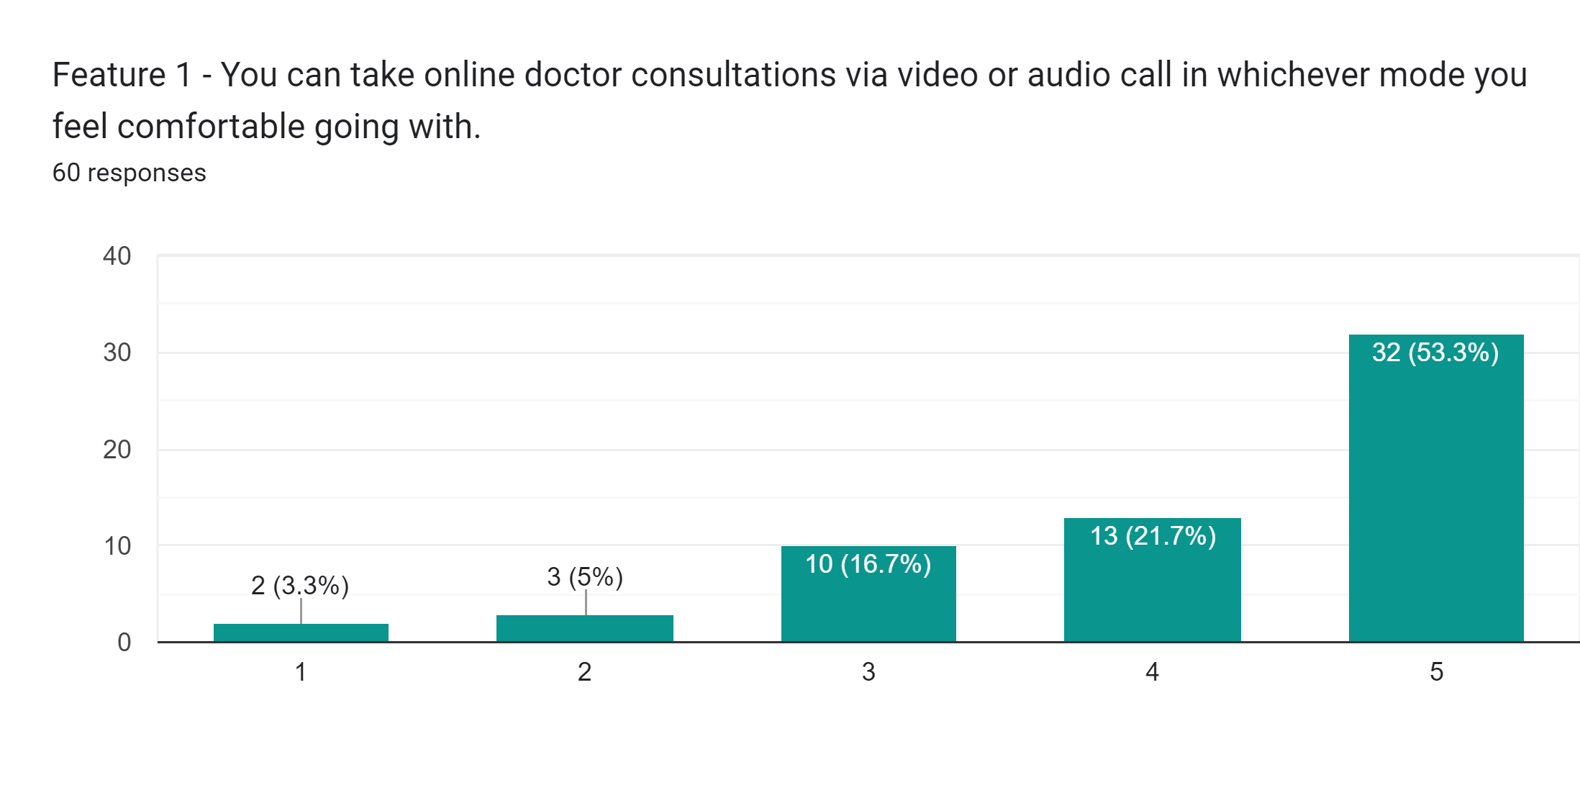User's data was collected through the Google forum to check how feasible and useful they find these features -

